1. The Cisco AnyConnect Secure Mobility Client must be running before the ODBC setup is attempted.

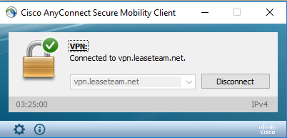

1. Open **ODBC Data Source Administrator (32-Bit)**. This can be found under Administrative Tools or, after installing Crystal Reports, it can be found as one of the programs under SAP Business Intelligence.

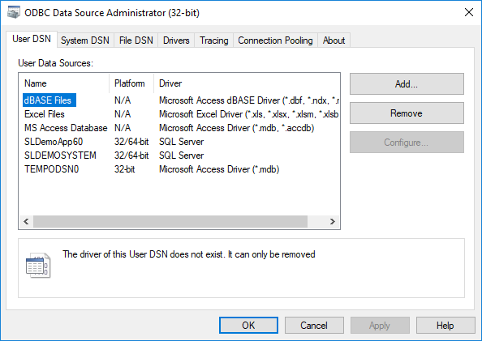

1. Click on the System DSN tab.

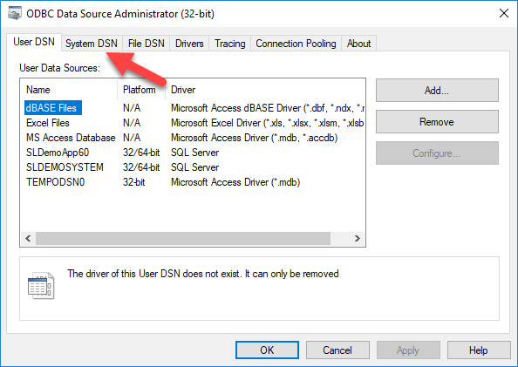

1. Click on the Add Button to add new connection.

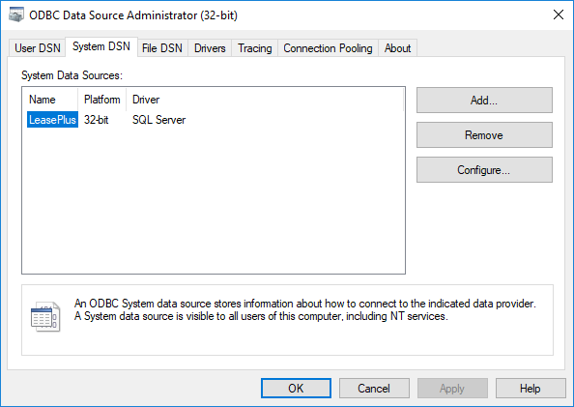

1. In the Create New Data Source screen, select SQL Server then click Finish.

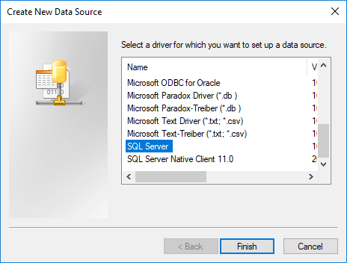

1. The name is LeasePlus, Description is LeasePlus and the Server is 10.12.17.193 then click Next.

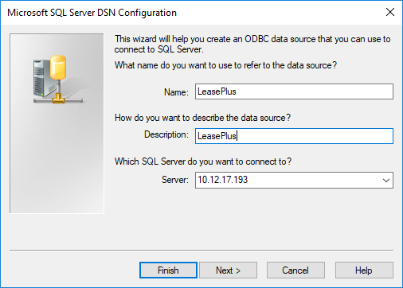

1. Click on the Client Configuration button.

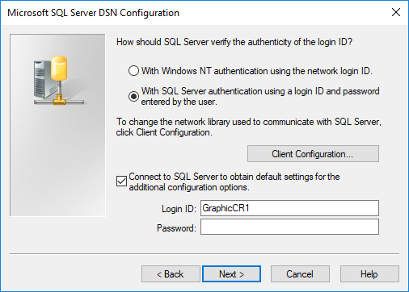

1. Uncheck the Dynamically Determine port then click OK.

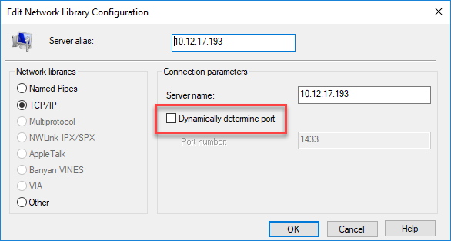

1. Bak to the Microsoft SQL Server DSN Configuration screen, select the *With SQL Server authentication using a login ID and password entered by the user* radio button.



1. The Login ID is GraphicCR1. The password is **lapel Loots be hP(** then click Next.
2. The default database of Master will be selected so you need to change the default database to LPGraphics then click Next.

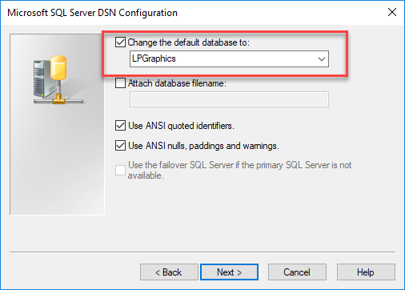

1. When the screen below comes up, click the Finish button.

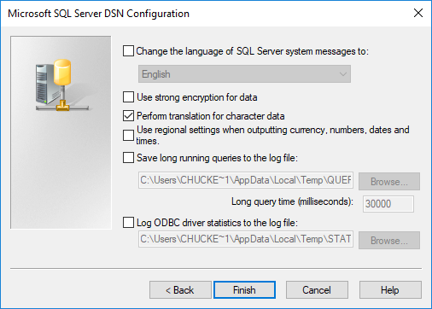

1. Then click the Test Data Source button.

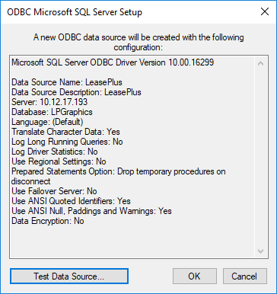

1. When you see the TESTS COMPLETED SUCCESSFULLY! Results, click OK then click OK on the following screen..
2. Your ODBC should be successfully set up.